ASSIGNMENT PCA - Face Image Compression

This assignment is about Principal Component Analysis algorithm applied in Face Compression. The goal is to solve PCA in Octave or Python and do reconstruction of the face image by using different number of PCA components, then print the “reconstruction error in the table below and submit for assignment.
The scripts and the data are on the …Public/week7 directory in Jupyter Notebook
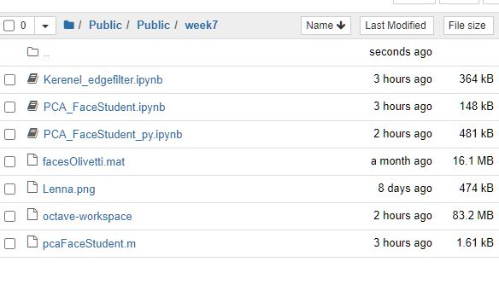
For MATLAB users the script to modify is PCA_FaceStudent.ipynb, please use Octave Kernel
For Python users the script to modify is PCA_FaceStudent_py.ipynb, please use Python Kernel
If you want to run this locally on your machine you need to download only two files, the program “pcaFaceDemoS.m” and input data “facesOlivetti.mat and load it into Octave tool.
Dataset is based on Olivetti data base at ATT, it has 400 total images,( 112x92 size), of grayscale faces 8bit[0-255] grouped by 10 images of the same person but from different angle.
Matrix X has 400x10,304 elements and each row has one image 112x92. We will test our compression with PCA on image 25.
Inside scripts there is
Python script:
# Step 4: Reconstruct the images using a subset of principal components
# Step 4: Compute MSE curve for 1–100 PCs
pcs_range = range(1, 101)
mse_curve = []

for k in pcs_range:
pca_k = PCA(n_components=k)
X_pca_k = pca_k.fit_transform(X_centered)
X_reconstructed_k = pca_k.inverse_transform(X_pca_k)
mse_curve.append(mean_squared_error(test_image, X_reconstructed_k[test_idx].reshape(1, -1)))

# Step 5: Plot results
plt.figure(figsize=(10, 8))

# Original image
plt.subplot(2, 2, 1)
plt.imshow(test_image.reshape(h, w), cmap='gray')
plt.title("Original Image")
plt.axis("off")

# Reconstructed with 10 PCs
plt.subplot(2, 2, 2)
plt.imshow(X_reconstructed_10[test_idx].reshape(h, w), cmap='gray')
plt.title("Reconstructed (10 PCs)")
plt.axis("off")

# Reconstructed with 100 PCs
plt.subplot(2, 2, 3)
plt.imshow(X_reconstructed_100[test_idx].reshape(h, w), cmap='gray')
plt.title("Reconstructed (100 PCs)")
plt.axis("off")

# MSE curve
plt.subplot(2, 2, 4)
plt.plot(pcs_range, mse_curve, marker='o')
plt.title("MSE vs Number of PCs")
plt.xlabel("Number of PCs")
plt.ylabel("Mean Squared Error")

plt.tight_layout()
plt.show()

Calculating the Mean Squared Error (MSE)
from sklearn.metrics import mean_squared_error

# Step 1: Select the test image (index 25)
test_idx = 25
test_image = X[test_idx].reshape(1, -1)

# Step 3: PCA with 10 PCs
pca_10 = PCA(n_components=10)
X_pca_10 = pca_10.fit_transform(X_centered)
X_reconstructed_10 = pca_10.inverse_transform(X_pca_10)

# Step 4: PCA with 100 PCs
pca_100 = PCA(n_components=100)
X_pca_100 = pca_100.fit_transform(X_centered)
X_reconstructed_100 = pca_100.inverse_transform(X_pca_100)

# Step 4: Calculate MSE for test image
mse_10 = mean_squared_error(test_image, X_reconstructed_10[test_idx].reshape(1, -1))
mse_100 = mean_squared_error(test_image, X_reconstructed_100[test_idx].reshape(1, -1))

print(f"MSE with 10 PCs: {mse_10}")
print(f"MSE with 100 PCs: {mse_100}")
#end code
Enter your lines of code between highlighted lines in the script for mapping from PC space to original space. After that run the program and you will get one plot with subplot of original image, image reconstructed with 10 PCs and image reconstructed with 100 PCs, and mean square error graph.
In the command window you will have print for error for 10 and 100 PC components used in reconstruction.
Please send me mean square error for reconstruction with 10 and with 100 PC components.
#PC(K) | 10 | 100
Mean square error | 0.31670206785202026 | 0.31114286184310913

Thank you!

